Muddy Creek 1
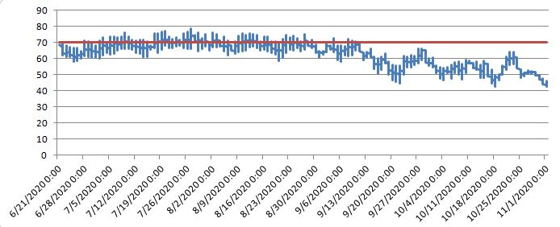
Minimum | 42.71
Maximum | 78.56
Average | 62.73

Elk/Pine 2
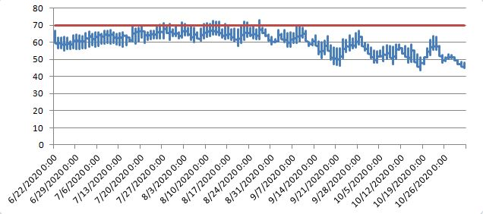
Minimum | 43.716
Maximum | 72.912
Average | 60.15451

Elk/Pine 3
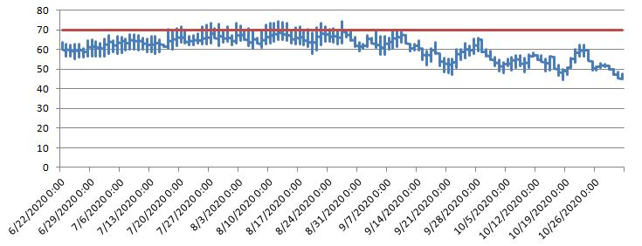
Minimum | 44.764
Maximum | 74.511
Average | 60.8446
Sinking Creek 2
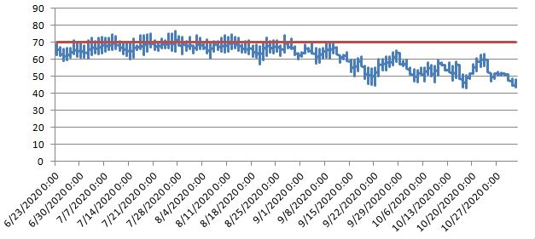
Minimum | 43.03
Maximum | 76.681
Average | 61.91844

Penns Creek 9
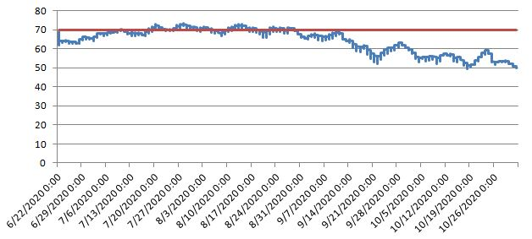
Minimum | 49.471
Maximum | 73.386
Average | 63.91418

Laurel Run 3
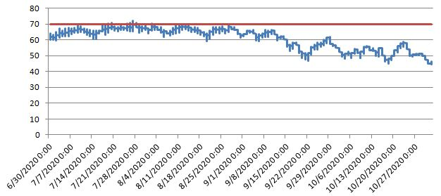
Minimum | 44.582
Maximum | 71.964
Average | 60.6436
Muddy Creek 2
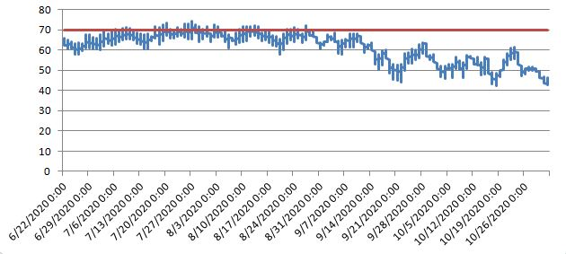
Minimum | 42.478
Maximum | 74.511
Average | 61.18998

Elk/Pine 4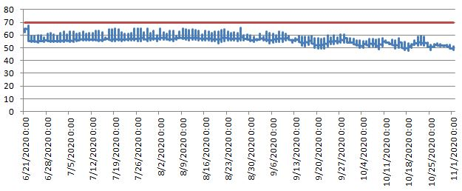

Minimum | 47.557
Maximum | 67.586
Average | 56.30929

Muddy Creek 1
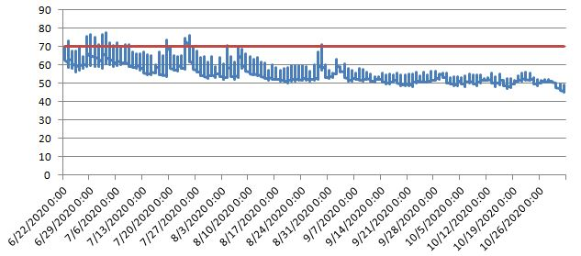

Minimum | 45.307
Maximum | 77.421
Average | 56.09146
Pine Creek 2
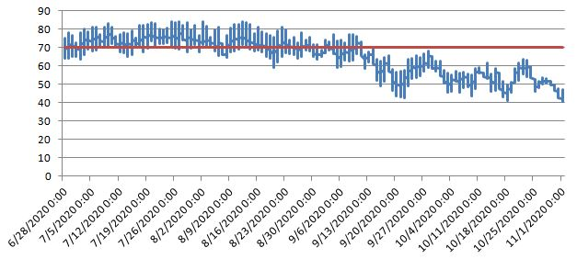

Minimum | 40.764
Maximum | 84.227
Average | 65.2076

Vonada Gap 1

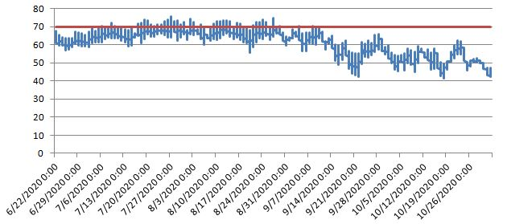

Minimum | 41.508
Maximum | 75.853
Average | 60.95274

Sinking Creek 1
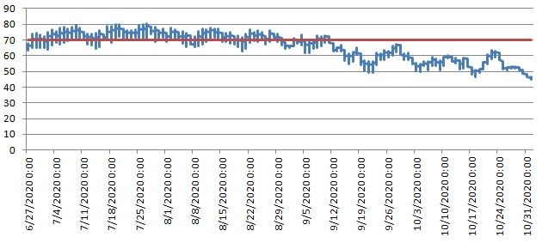
Minimum | 45.036
Maximum | 80.492
Average | 65.47865
Elk/Pine 1
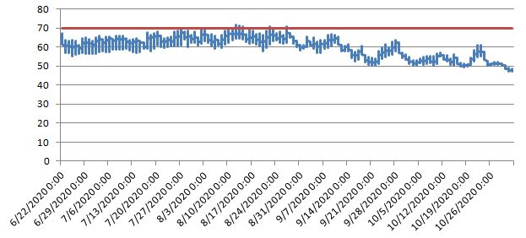
Minimum | 47.244
Maximum | 71.704
Average | 59.59658

Pine Tributary 2
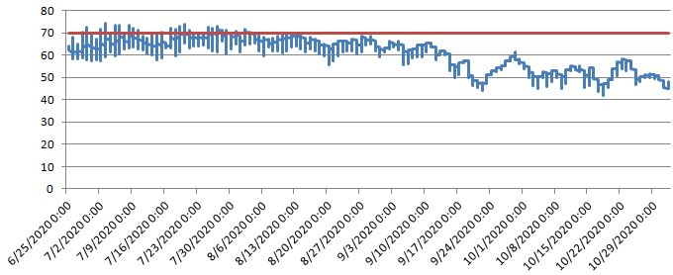

Minimum | 41.878
Maximum | 74.554
Average | 59.68628

Penns Creek 8
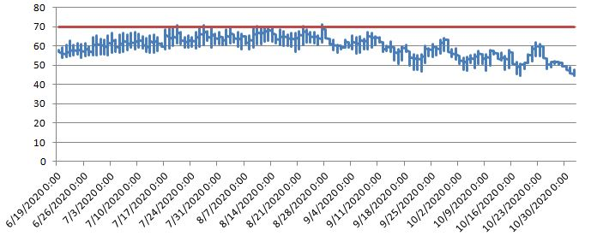
Minimum | 44.492
Maximum | 71.317
Average | 58.94579

Elk Creek 2
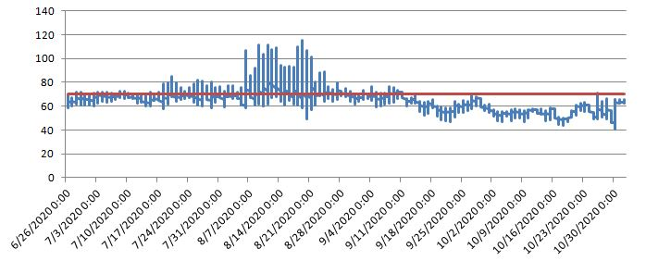
Minimum | 40.532
Maximum | 114.978
Average | 64.65333

Penns Creek 1
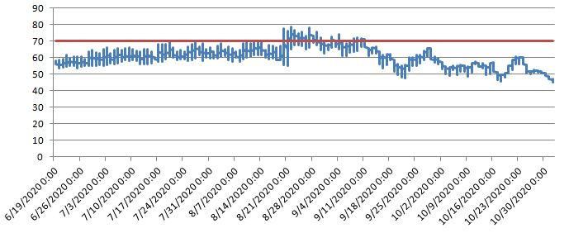
Minimum | 45.399
Maximum | 78.559
Average | 60.07542

Pine Tributary 3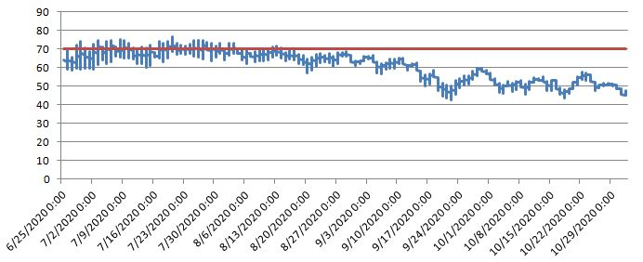
Minimum | 42.525
Maximum | 76.464
Average | 60.8292

Pine Tributary 4
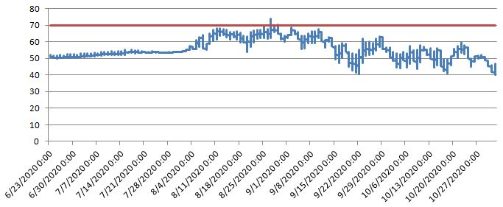
Minimum | 39.924
Maximum | 73.774
Average | 55.71418

Pine Creek 1
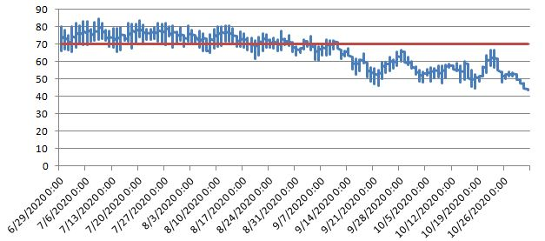
Minimum | 43.671
Maximum | 84.407
Average | 65.75452

Pine Voneda 1
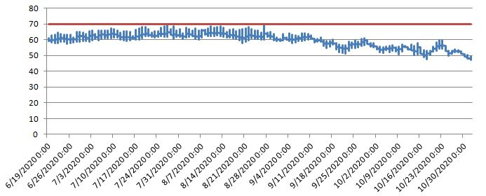
Minimum | 47.289
Maximum | 69.256
Average | 59.60213

Low battery:
299- Case Pine Tributary 1
509 Bzdil Pine Pine Tributary 3
510 Bzdil Voneda Pine Voneda 1
507 Toolshed Penns Creek 2
293 Marquardt/Muddy Creek Bridge Muddy Creek 4
506 Sherwin Penns Creek 1

