Elk/Pine 1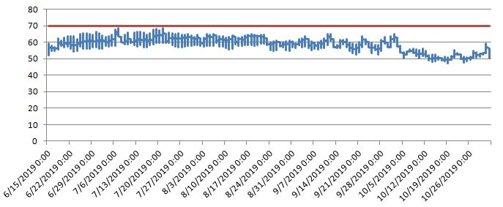
Minimum | 47.422
Maximum | 68.614
Average | 58.41484

Elk/Pine 2
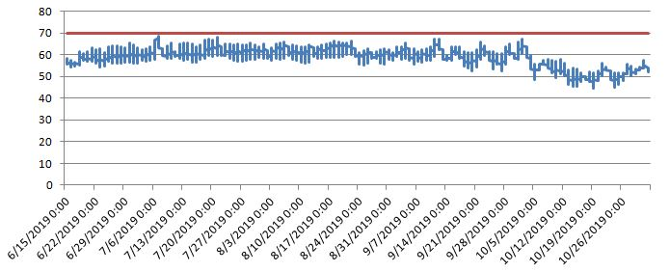
Minimum | 44.4
Maximum | 68.614
Average | 58.75125

Elk/Pine 3
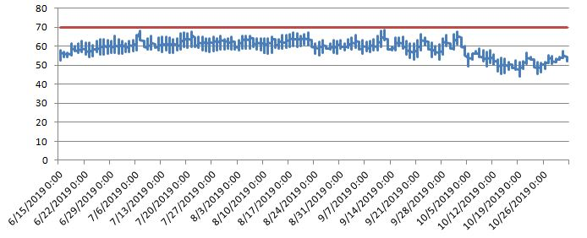
Minimum | 44.355
Maximum | 68.527
Average | 58.99114

Elk/Pine 4
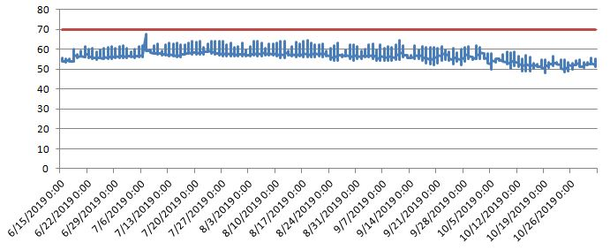

Minimum | 47.959
Maximum | 67.627
Average | 56.7666

Pine Tributary 2
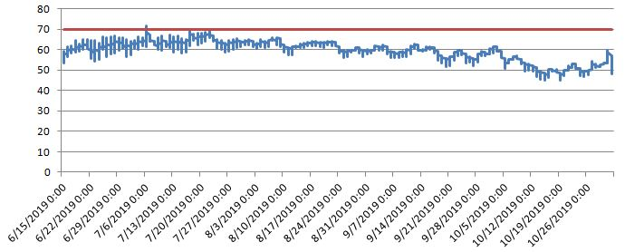

Minimum | 44.901
Maximum | 71.49
Average | 59.02766

Pine Tributary 5
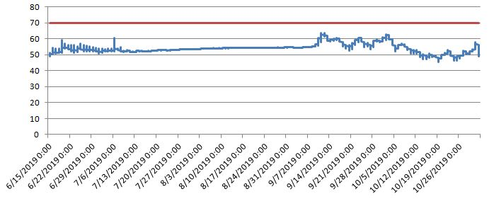

Minimum | 45.624
Maximum | 63.732
Average | 53.93248

Pine Creek 1
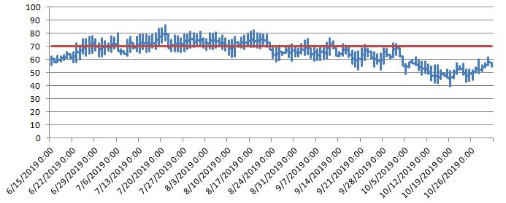
Minimum | 39.783
Maximum | 86.074
Average | 65.30953

Pine Creek 2
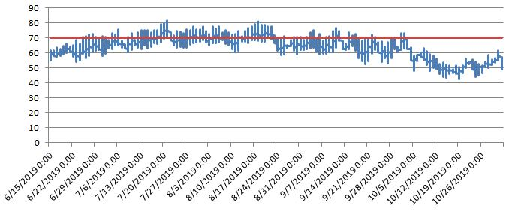

Minimum | 42.663
Maximum | 81.775
Average | 63.94417

Pine Tributary 4
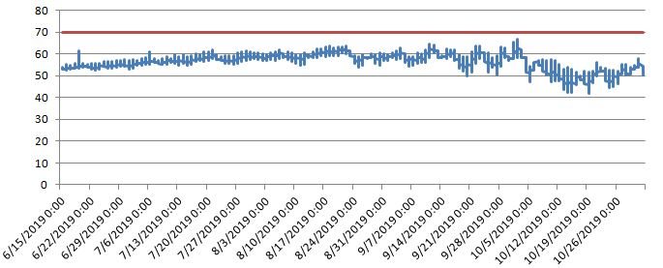

Minimum | 42.109
Maximum | 66.643
Average | 56.51384

Pine Tributary 3
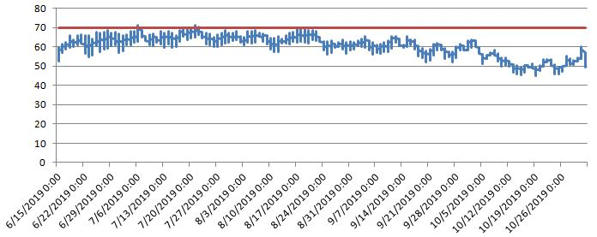
Minimum | 45.036
Maximum | 71.231
Average | 60.19539

Pine/Voneda 1
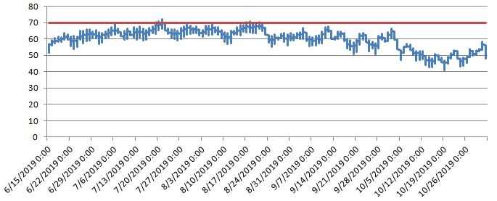

Minimum | 41.137
Maximum | 72.093
Average | 59.80966

Muddy Creek 3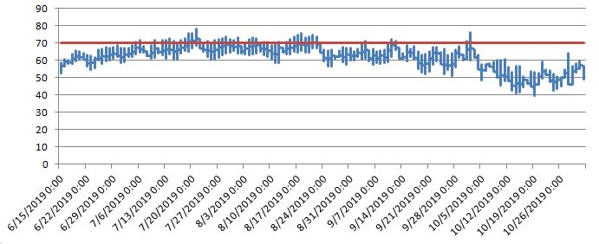
Minimum | 39.596
Maximum | 77.945
Average | 61.98222

Sinking Creek 2
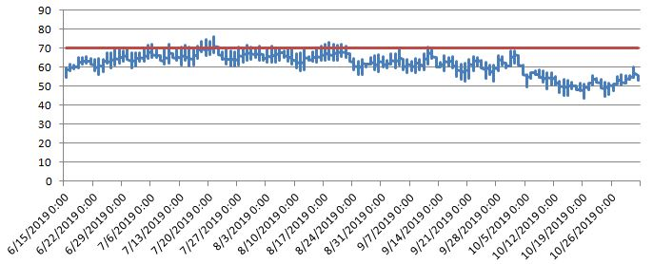
Minimum | 43.443
Maximum | 76.289
Average | 61.63612

Penns Creek 9
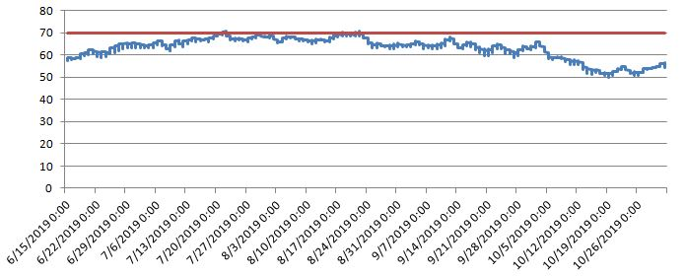
Minimum | 49.737
Maximum | 71.017
Average | 62.8251

Laurel Run 3
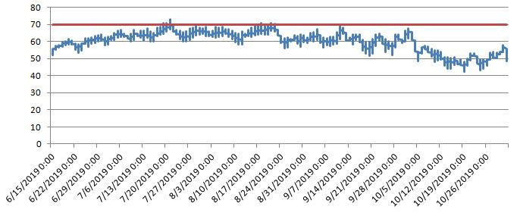
Minimum | 42.247
Maximum | 73.083
Average | 60.09576

Muddy Creek 2
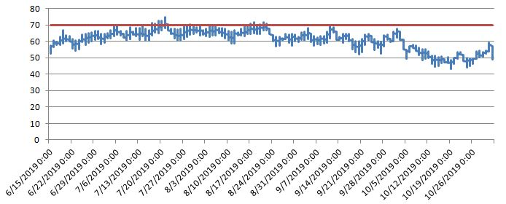
Minimum | 43.075
Maximum | 74.77
Average | 60.89329
Muddy Creek 1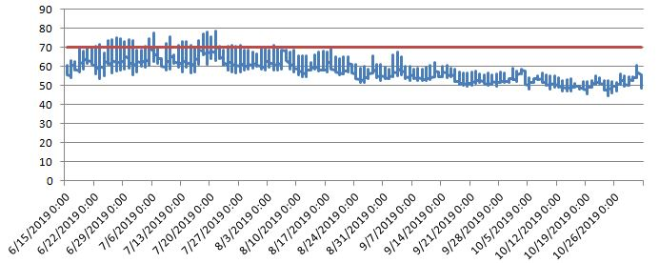
Minimum | 44.719
Maximum | 78.645
Average | 58.48979

Vonada Gap 1
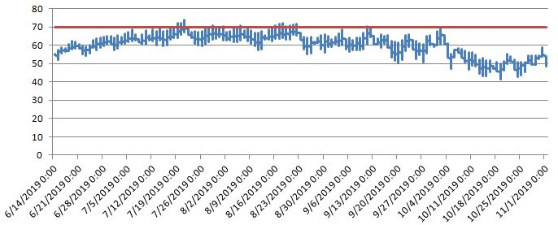

Minimum | 41.416
Maximum | 74.077
Average | 60.35456

Sinking Creek 1
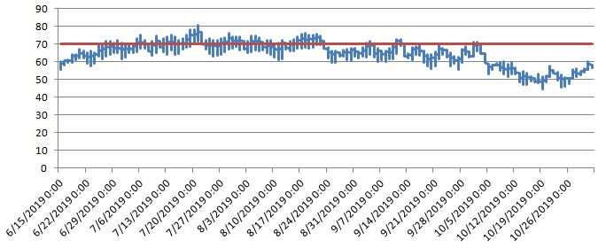
Minimum | 44.492
Maximum | 80.625
Average | 64.26939

Penns Creek 8
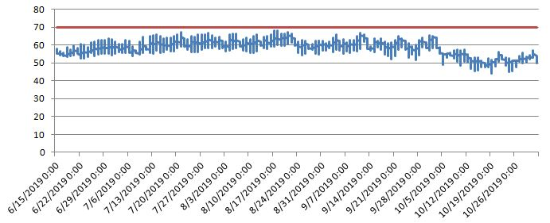
Minimum | 44.082
Maximum | 68.185
Average | 57.91178

Elk Creek 2
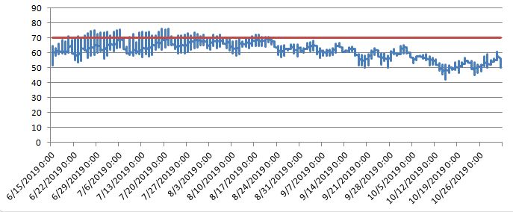
Minimum | 42.017
Maximum | 76.289
Average | 61.70812
Elk Creek 1
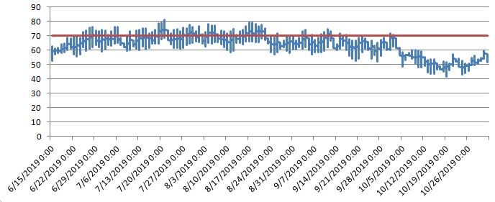

Minimum | 41.416
Maximum | 81.023
Average | 63.0256

Penns Creek 3
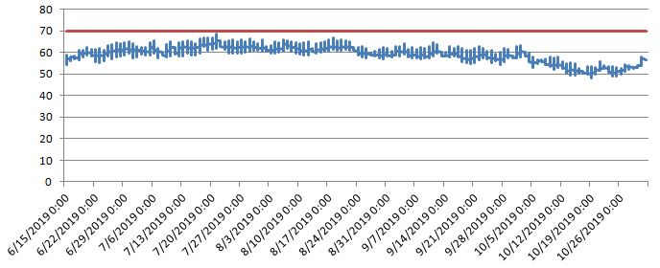
Minimum | 48.004
Maximum | 68.527
Average | 59.08488

Penns Creek 2
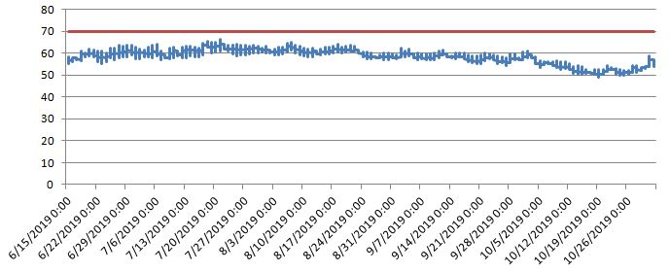
Minimum | 49.073
Maximum | 66.385
Average | 58.44331

Penns Creek 4
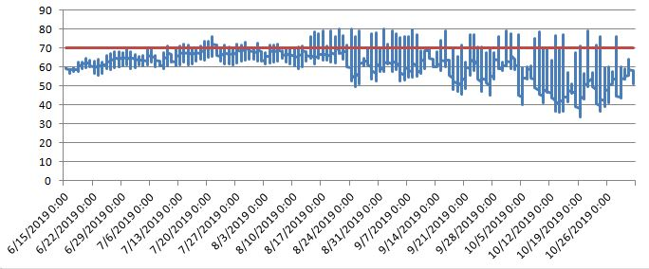
Minimum | 33.732
Maximum | 79.963
Average | 61.55238

Penns Creek 5
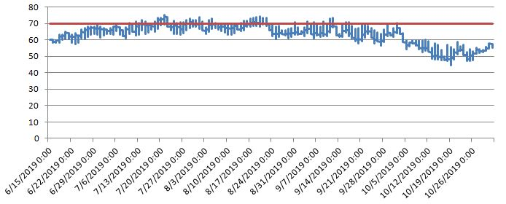

Minimum | 44.582
Maximum | 75.333
Average | 63.58273

Muddy Creek 4
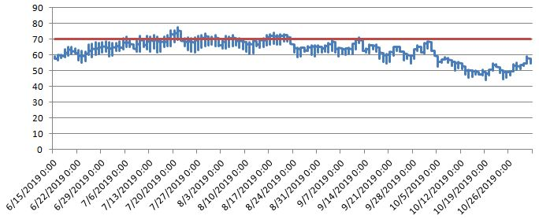
Minimum | 44.31
Maximum | 77.902
Average | 62.47374

